**CTF Topic: Controlling Script Execution with NoScript Security Suite**

**1. Introduction**

NoScript Security Suite is a Firefox extension that allows users to block potentially harmful scripts and content on websites. It is a powerful tool for enhancing security by allowing selective execution of JavaScript, Java, Flash, and other plugins.

**2. Tools and Requirements**

Mozilla Firefox browser  
Install the [NoScript Security Suite Firefox extension]

(<https://addons.mozilla.org/en-US/firefox/addon/noscript/?utm_source=addons.mozilla.org&utm_medium=referral&utm_content=search>)

**3. Scenario**

As a participant in this CTF challenge, your task is to use the NoScript Security Suite extension to manage and control the execution of scripts on <http://testphp.vulnweb.com/>. Modify the settings and answer the following questions based on your observations.

Begin

1. Install the NoScript Security Suite Firefox extension from the provided link: <https://addons.mozilla.org/en-US/firefox/addon/noscript/?utm_source=addons.mozilla.org&utm_medium=referral&utm_content=search>  
2. Visit <http://testphp.vulnweb.com/> and use the extension to control the execution of scripts and other content.  
3. Utilize the extension features to answer the questions.

Questions and Answers

Flag 1: After installing NoScript, what is the default behavior for script execution on `http://testphp.vulnweb.com/`?

Answer: Scripts are blocked by default.

Flag Captured.

Flag 6: How can you permanently allow scripts from a trusted domain?

Answer: Click on the NoScript icon and select "Allow domain" to permanently allow scripts.

Flag Captured.

Hint

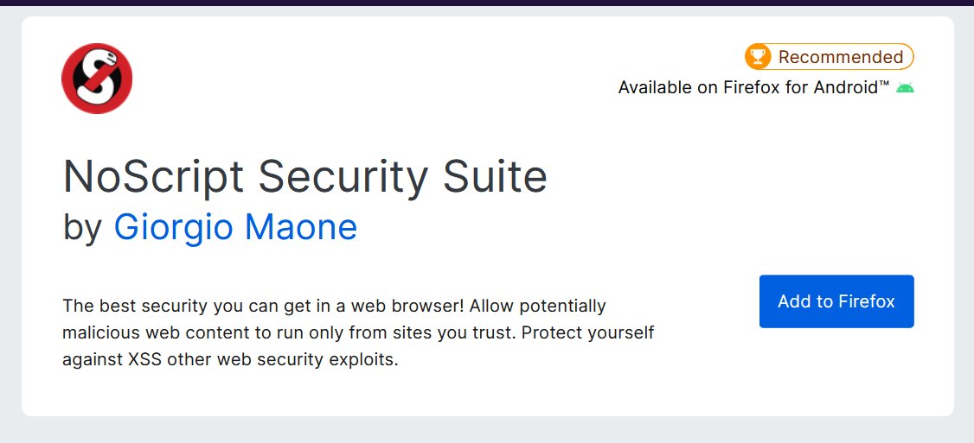

Install the NoScript Security Suite Firefox extension and use it to manage and control the execution of scripts and other content on `http://testphp.vulnweb.com/`. Adjust settings as required to answer the questions accurately.